Assignment 6
Regular Expressions (REGEXP)

Exercise 1.
SELECT * FROM Patient, Doctor WHERE Patient.PFirstName REGEXP 'A';
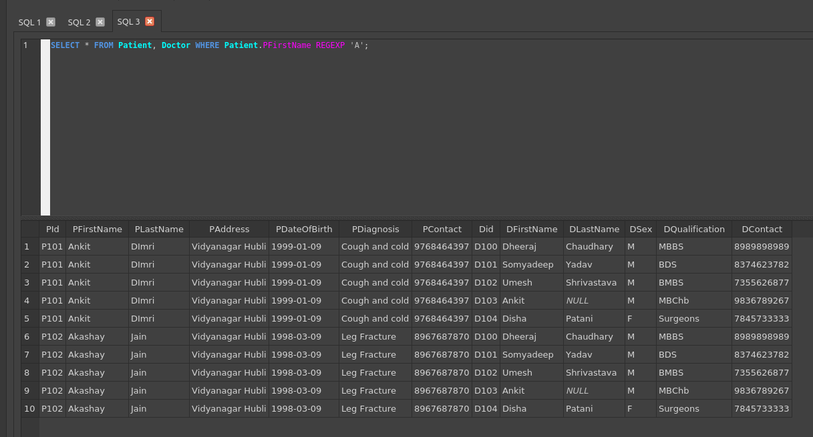

Exercise 2.
SELECT * FROM Patient WHERE PFirstName REGEXP '^[Soj]';
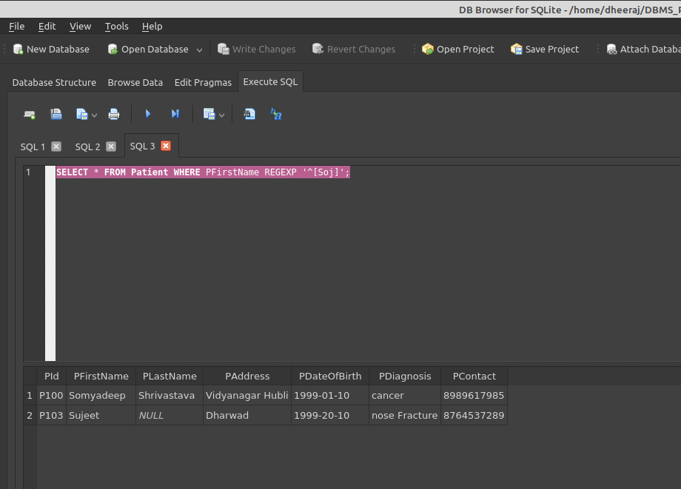

Exercise 3.

SELECT * FROM Patient WHERE PFirstName REGEXP '^[^Soj]';
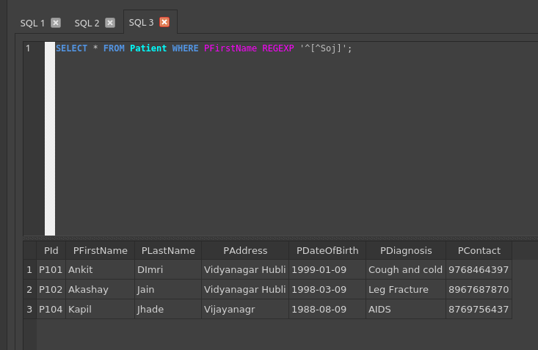

Exercise 4.

SELECT * FROM Patient WHERE PFirstName REGEXP 'om*';
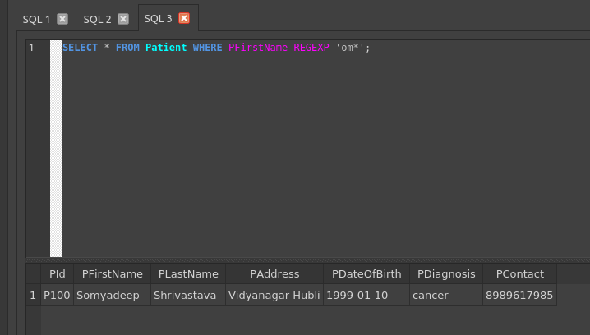

Exercise 5.

SELECT * FROM Patient WHERE PFirstName REGEXP 'uj+';
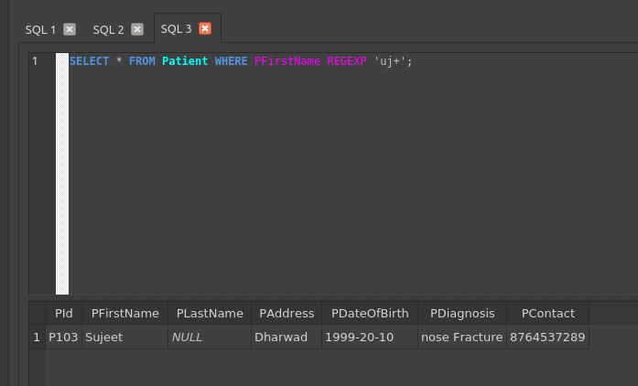

Exercise 6.

SELECT * FROM Patient WHERE PFirstName REGEXP 'omy?';
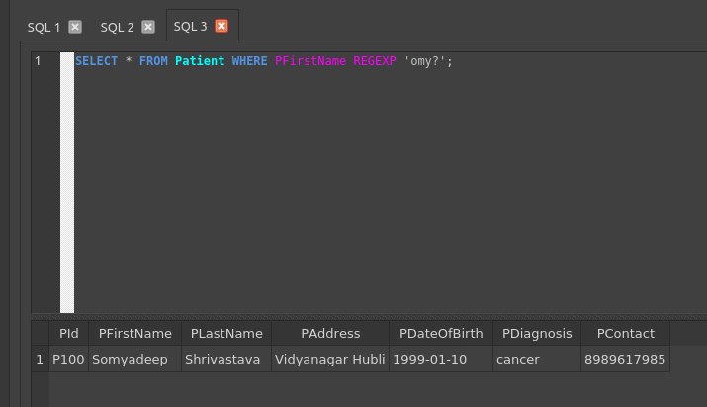

Exercise 7.

SELECT * FROM Patient WHERE PFirstName REGEXP 'Ank.';
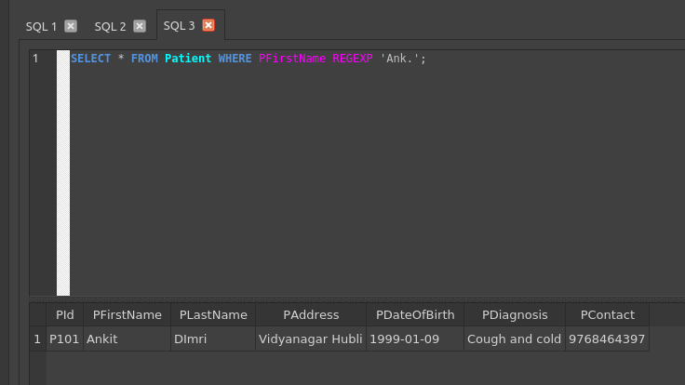

Exercise 8.

SELECT * FROM Patient WHERE PFirstName REGEXP '[A-Z]';
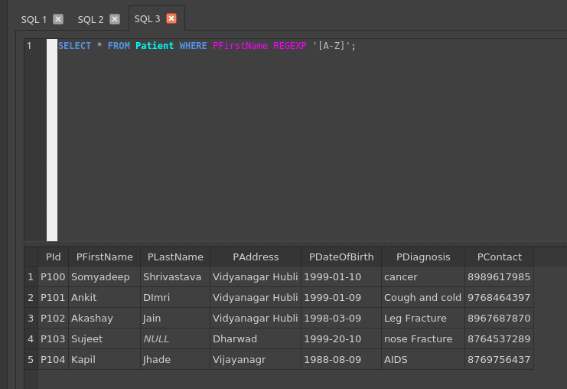

Exercise 9.

SELECT * FROM Patient WHERE PFirstName REGEXP '[0-9]';
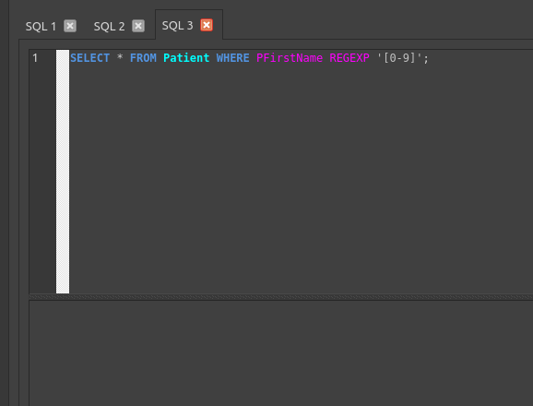

Exercise 10.

SELECT * FROM Patient WHERE PFirstName REGEXP '^[Som]|^[uj]';
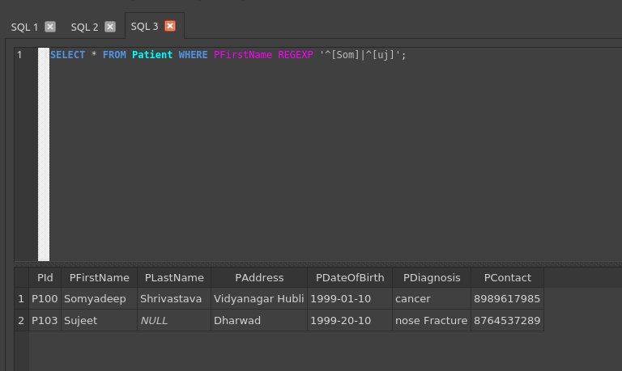

Exercise 11.

SELECT * FROM Patient WHERE PFirstName REGEXP '\bSom';
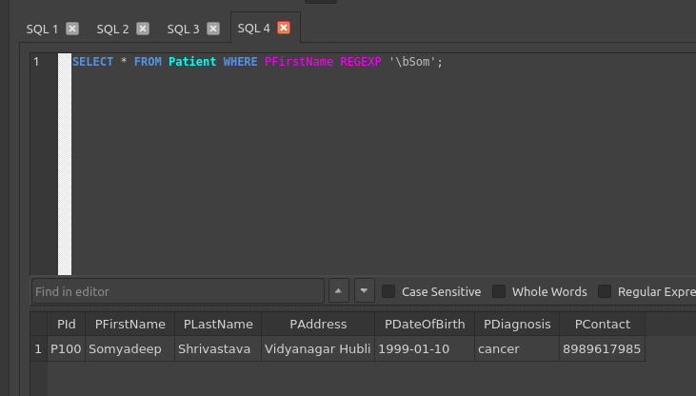

Exercise 12.

SELECT * FROM Patient WHERE PFirstName REGEXP '[:alpha:]';
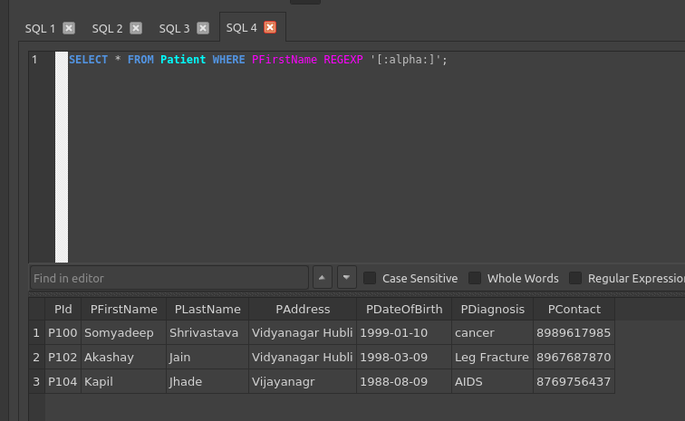

Reference Below table for above Queries
Table 1. (Doctor)
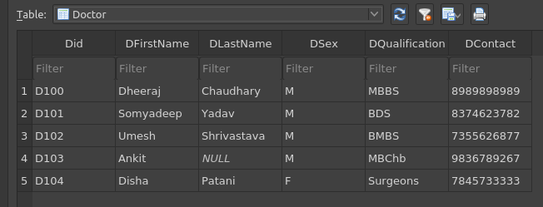
Table 2. (Patient)
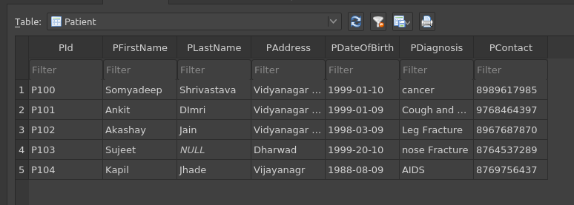
Table 3. (Hospital)
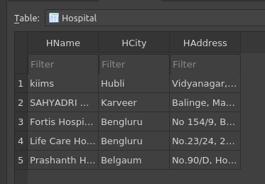

Table 4. (Medical Record)
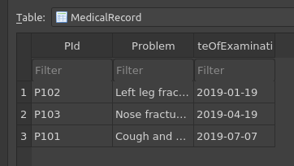

Table 5. (Nurse)
